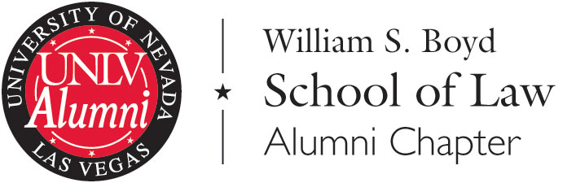

Board Nomination Form – Please submit by June 10, 2014

Personal Information

Name:
Graduation Year:
Home Address:
Cell Phone:
Personal Email:

Employment Information
In lieu of completing any field, you may attach your resume and state “see resume” in the field.

Employer:
Title:
Business Address:
Business Phone:
Business Email:
Practice Area(s):

Application Questions
List the ways that you have been involved in law school alumni activities, including events attended, volunteer work, and other formal or informal involvement with Boyd Law. (As you type, the text box will expand.)

List the student organizations/activities you were involved in during law school.

List your past and current involvement with other legal, educational, or community organizations/activities.

Why are you interested in being a Boyd School of Law Alumni Chapter Board Member?

What are your ideas for how to help alumni stay connected and engaged with the Boyd School of Law?

Instructions

You are welcome to include recommendations from fellow Boyd graduates and others who can attest to your enthusiasm for the Boyd School of Law. These may be submitted along with your completed application to carolyn.barnes@unlv.edu by June 10. If you have questions about the Boyd Alumni Chapter Board, please contact Carolyn Barnes, Director of Alumni Relations, at carolyn.barnes@unlv.edu or 702-895-2450.

Thank you for your interest in the William S. Boyd School of Law.

