3RD FUTURE OF ESPORTS IN NEVADA SUMMIT
SPEAKER PROFILES

KEY NOTE SPEAKER:
Neil Duffy – Vice President, Collegiate StarLeague
Collegiate StarLeague (CSL), the largest collegiate esports community in the world. CSL hosts competitive video game leagues and tournaments across over 1000 college campuses in the US and Canada. With more than 35,000 registered student-gamers playing top titles like League of Legends, DotA2 and CSGO, CSL expanded this year to include mobile and console titles to its roster, notably hosting the Madden 17 Collegiate Championship in association with EA Sports. Neil also worked as EVP of Operations for the International eGames Committee (IeGC), a British government supported initiative that launched an Olympic style event called the eGames in August 2016 in Rio de Janeiro, Brazil.

 Ian Seltzer – Director of Content & Business Development at Rogue esports
Before joining Rogue, Ian worked for Hulu, Vuguru (Michael Eisner's digital studio), and Paramount Digital Entertainment covering content creation, licensing, distribution and digital marketing. He has developed, licensed and launched thirty original titles for TV, film and the web in over 110 countries worldwide. He also worked in developing esports, media and entertainment verticals for early stage investment at Pierce Yates Ventures.

Ian graduated with a BA in History from the University of Pennsylvania and subsequently earned an MS with Merit in Media and Communications from the London School of Economics with a research focus on monetizing streaming media content in the U.S. Ian is an active Penn alumnus as a member of the University Library’s Digital Media Awards Committee and the Annenberg School of Communications Performing Arts Council.
https://www.linkedin.com/in/ian-seltzer-75793726

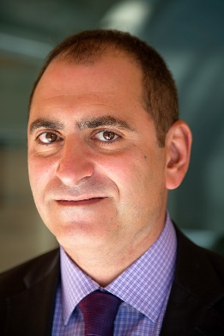Alex Igelman – CEO Millennial Esports Corporation
Alex is a lawyer by education and strategic consultant with over 25 years of experience in gaming, technology and entertainment. Prior to his role as CEO of Millennial Esports Corporation, Alex was a successful gaming and entertainment lawyer and was the founder of Gaming Research Partners, a gaming strategy consulting firm. During his career, Alex has provided strategic services to numerous public and private companies including leading brands in gaming and entertainment such as GamingVC, PartyGaming, Pokerstars, Wynn Resorts, Caesars, MGM and others. Alex is a member in good standing of The Law Society of Upper Canada and on the editorial board of the Gaming Law Review and Economics

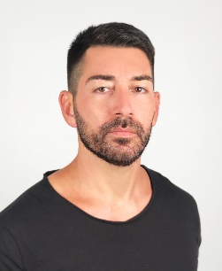Ronn Nicolli – Senior executive director marketing Wynn nightlife
Coming from humbling beginnings as a promotions host to becoming one of Las Vegas nightlife’s most respected and influential marketing minds, Ronn Nicolli joined the Wynn Las Vegas nightlife team in 2005. As the marketing executive for Tryst and XS, he has been creating and developing marketing collateral and assets for the venues, DJs, branded parties and concepts while assisting in creative direction. He will spearhead all Intrigue marketing initiatives including liaison programs with restaurants on property and off-site installations.
Born in Youngstown, Ohio, Nicolli began his nightlife career in a low-level position at La Bête Nightclub after running a personal fitness business. His nightlife marketing prowess was immediately evident and he has continued to make professional strides ever since. In 2015, Vegas Inc. honored Nicolli at its “40 Under 40” award show.

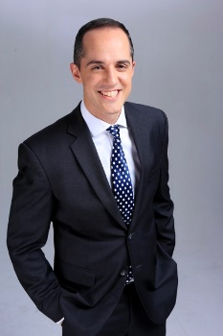Jud Hannigan – CEO Allied Esports international
Jud has been a part of the company since its founding in 2015. In addition to guiding the strategic development of new competitions, content development and partnerships with a mission to expand the company’s global footprint, Jud overseas the company’s operations in North America and Europe.

Prior to Allied Esports Jud founded and managed consulting and trading firm Big Turn International in Beijing from 2006-2016 where he worked with clients across Asia in a vast number of industries including Sports and Entertainment, Gaming, Television, Apparel, Media, Pulp & Paper, Architecture, and E-Learning.

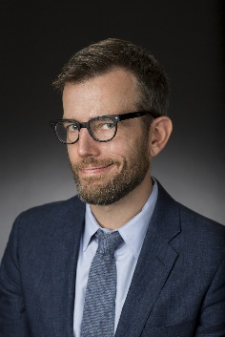Chris Grove – Managing Director Eilers and Krejcik Gaming
Chris Grove is a gambling industry analyst. A managing director at Eilers & Krejcik Gaming, Grove also oversees trade publications covering regulated online gambling, esports, and DFS. Grove serves on the board of advisors for regulated esports betting site Unikrn.com and Las Vegas-based esports organization Rogue.gg. His expertise has been cited by lawmakers, regulators, and major media outlets such as the New York Times, the Washington Post, ESPN, and the Wall Street Journal.

Ian Smith – Integrity Commissioner – Esports Integrity Coalition
Ian Smith has been the esports integrity commissioner since early 2016. He is a UK lawyer with over 20 years’ experience in traditional sports, primarily in regulation and governance. His particular focus has always been the connection between the athlete and the rules and regulations that govern the athletes’ professional life. Ian left private practice in 2004 to go in-house as legal director of the Professional Cricketers’ Association in the UK where he was responsible for advising players on a range of issues, but also negotiating, on their behalf, the contracts, rules and regulations that applied to them, such as the Anti-Doping and Anti-Corruption Codes. For two years between 2013 and 2015 Ian also ran the Federation of International Cricketers Associations (FICA), the umbrella body for all the Player Associations in International cricket, which meant he dealt with the terms and conditions under which players participated in the Cricket World Cup, the World T20 Championships and the Champions Trophy and was the player representative on the Security Directorate of all major events through to 2015. He sat on the Athletes Committee of UK Anti-Doping for five years.

